AgileDogs at JAZZ, Greenfield Center, NY Presents:
Scent Work Seminars with Trisha Stall February 22, 2026
Scent Work Skills Building (Handling and Communicating)
Intro to Scent Work

Who can attend? Scent Work Skills: any dog who has taken at least one session of Scentwork or is currently trialing in scentwork. Intro to Scent Work: any dog that has not taken a scent work class or is just beginning in scent work.
What’s the cost? $65 for each seminar. Limit 8 working Teams.
Can I audit? Auditing is available for the AM Scent Work Skills Building Seminar only, $35 per person.
What’s the schedule? 8:30 AM – 12 PM Scent Work Skills Building 1 PM – 4:30 PM Intro to Scent Work
Can I work a second dog? You may only work one dog at a time. However, if you want to substitute a second dog working at a similar or higher level to your first dog, please contact us so we can approve the substitution.
Are cancellations allowed? For cancellations more than 2 weeks prior to the workshop, before 1/16/26 full refund is available. For cancellations less than 2 weeks prior to the workshop, no fees will be refunded unless we can fill your spot. Bitches in season and aggressive dogs are not allowed on the grounds. If you plan to attend with an intact bitch, you should plan ahead and arrange to have an alternate dog of similar skill level available to work. No refunds for bitches in season unless you cancel before 1/16/26.
I’m coming! How do I sign up? Registration opens on 1/8/26 starting at 9am, preference given to current AgileDogs students, Email Trisha agiledogs@outlook.com to save your spot. Then send this form within 7 days with check/MO made out to AgileDogs, to Trisha Stall, 37 S. Greenfield Rd., Greenfield Center, NY 12833. Alternately, you may pay via Venmo or Paypal, for an additional 3% fee. If you wish to do this please note it when you contact Trisha and she will tell you the amount due and how to pay. There will be a $25 fee for returned checks. Questions? Email Trisha Stall, agiledogs@outlook.com

Registration Form – Trisha Stall Scent Work Seminars – February 22, 2026

Name: ________________________ Address: __________________________________________________________

Phone Number: ________________________ Email Address: ______________________________________________

Dog’s Name: ______________________ Breed(s): ___________________________________ Age: ________ M/F: ___

2nd Dog’s Name: ___________________ Breed(s): ___________________________________ Age: ________ M/F: ___

Seminar: Scent Work Skills Building: ______________ (dog’s name) $65
Intro to Scent Work: _______________ (dog’s name) $65

Release form AgileDogs Agility Training and JArthur Enterprises LLC Waiver: I (we), the undersigned, agree to hold AgileDogs Agility Training and JArthur Enterprises, LLC, including their members, officers, directors, agents and employees, and owners of the premises upon which events are held and their employees, harmless from any claim for loss or injury that may have been alleged to have been caused directly or indirectly to any person or thing by the act of this dog while in or upon the premises or grounds or near any entrance thereto, and I (we) personally assume all responsibility and liability for any such claim. I (we) further agree to hold the aforementioned parties harmless from any claim for loss of this dog by disappearance, theft, death or otherwise, and from any claim for damage or injury to the dog, whether such loss, disappearance, appearance, theft, damage or injury, be caused or alleged to be caused by the negligence of the parties aforementioned, or by the negligence of any other person, or any other cause or causes. I (we) hereby assume the sole responsibility for and agree to indemnify and save the aforementioned parties harmless from any and all loss and expense (including legal fees) by reason of the liability imposed by law upon any of the aforementioned parties for damage because of bodily injuries, including death at any time resulting there from, sustained by any person or persons, including myself (ourselves) or on account of damage to property arising out of or in consequence of my (our) participation in events at this facility, howsoever such injuries, death or damage to property may be caused, and whether or not the same may have been caused or have been alleged to have been caused by negligence of the aforementioned parties or any of their employees or agents or any other persons.
I understand that AgileDogs or JArthur Enterprises LLC has the right to expel my dog, without a refund, for inappropriate conduct or aggressive behavior as determined by the instructor.

Signature – Owner or Parent / Guardian if Minor Date

For office use only: Pd Amt: $_______ Date _____________ Check # ___________ Received by: _____________
Scent Work Skills Building Seminar Description:
At its core, scent work is about using the dog’s natural ability to sniff things. However, there is a lot more than just telling the dog to “find it” and then calling “Alert!”. This seminar will teach you as the handler how to leash handle (not get in your dog’s way, yet support him), and teach both you and your dog how to communicate about where the hide is and how to better support each other on searches. Also, you will learn how to read your dog’s mood and stress level as he searches.
Intro to Scent Work Seminar Description:
This seminar will teach you and your dog the basics of the exciting world of scent work, the sport that all dogs with a nose can excel in! In addition to giving an introduction to what this sport is about, all the dog and handler teams will get instruction in the beginning steps of scent work using a variety of games and exercises.

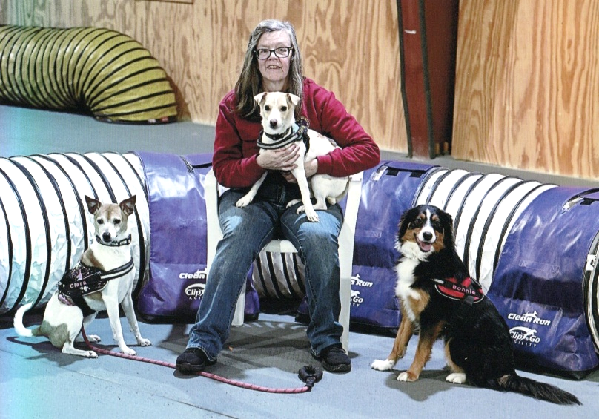
TRISHA STALL
Trisha has been a dog trainer since 1995, and the owner of AgileDogs Agility Training since 1999. Since the early years of AgileDogs, Trisha has been at the forefront of new sports, including teaching classes in and hosting some of the first ever APDT Rally Obedience Trials starting in 2001, and in 2020 teaching classes in and hosting CPE Canine Scent Sport (CSS) Trials. AgileDogs continues to teach and hold trials in agility, scent work, and Rally Obedience.
Trisha has trained 5 dogs in scent work and currently competes with 3 dogs in CPE CSS trials. In CPE one of her dogs is working on her SNITCH (Sniffing Team Champion). Her other 2 dogs are at levels 5 and 3 in CPE, and she has just begun AKC Scent Work trialing with 2 of her 3 dogs; one dog already has the Novice Containers and Novice Interiors titles after just 2 days of trialing!
Clara has competed at CPE CSS nationals every year since 2022, and in 2022 earned 10 for 10 Q’s, earned a third place in Interiors Round 1, and placed 1st Overall in Interiors. In the 4 years she has competed she has earned 25 out of 40 possible Q’s. Scooter also competed in CSS nationals in 2024, with step-in handler Bob Domfort, and earned 7 for 10 qualifiers.
Trisha first trained with Laura Clute, and has learned and continues to learn through webinars from such great trainers as Sue Sternberg, Tony Gravley, Dana Zinn, and Michele Ellertson.
Trisha became a CPE CSS judge in 2025, and enjoys watching how teams work and helping them to succeed at trials.

